Angles Stem Lesson Ladder

PROGRESSION
Essential Foundational Knowledge (Roots) | - Corners as attributes of shapes  - Spatial orientation and turning  - Later in stem – fractions and “1/4 of whatever” language
Leads to | - angle relationships  - intersecting lines (vertical angles)  - transversals and parallel lines  - polygon angle sums  - similarity/congruence proofs  - radians & trigonometry
Big Ideas | - “corner” is a colloquial idea with two coordinated meanings: a shape and a turn. “Angle” is a geometric object – two rays and a shared vertex - no ambiguity, no double meaning.  - We use “turning” to embody the general idea and to bridge from corner to angle, but the turning action is not a mathematical definition. The static definition (two rays, vertex) and the dynamic action (rotation from one ray to another) should be mutually reinforcing, not competing definitions. Doug & Julie’s upper levels explicitly require coordinating both.  - We’re measuring angles here. Just like all measurement, we choose a unit, then express measures as multiples of that unit. The units we’ll use are fractions of a turn or degrees. We make degrees on a circle the same way we make fractions on a number line. take the whole circumference and partition it into 360 equal arcs. One of those arcs has a measure of one degree. Degree (partitioning a circle into equal arcs) is exactly “unit iteration,” just on a circle instead of a line.  - Angle additivity: CCSSM makes “angle measure is additive” an explicit grade 4 expectation and uses it for unknown-angle problems.  Wu explicitly justifies additivity by thinking about arcs on the unit circle: the intercepted arcs concatenate, so the degree measures add. Angle measure additivity is a little glimpse into future more formal geometry and measurement
Other Information | - Benchmarks anchor intuition and precision: 90°, 180°, 360° function as reference points  - Invariance: angle size is independent of length/orientation. This is a conceptual “upgrade”: students learn to ignore irrelevant features (segment length, endpoint distance, rotation on the page). Doug & Julie treat this as a major conceptual hurdle with documented misconceptions.  - From empirical measurement to deductive geometry. Experience measuring angles builds both intuition and a stock of properties that later become explicit/precise and power deductive proof.  - Doug & Julie list several common errors:  - judging angle size by segment length or endpoint distance,  - thinking “straight” means vertical/not vertical (mixed everyday meanings),  - thinking right angles differ by orientation,  - interpreting “right angle” as “points to the right.”  - warn that without instruction, many students may not reach the higher “Angle Size Comparer/Angle Measurer” levels even by the end of elementary  - (optional but nice for teacher background). 360 is tied to base-60 traditions and has many factors, making common fractional turns land on whole-number degrees, which simplifies work  - Protractor use is not trivial and needs explicit instruction

Concept/Skill: (Megan—DONE)

Make and describe turns)

Goals | - follow and give turn directions (turn left/right; turn more/less)  - distinguish “turn amount” from “distance traveled”  - compose turns informally (“two turns makes a bigger turn”)
Student-Facing Example | Using Blocks to Learn about Angle and Turn  - Help the children become familiar with aspects of angle and turn by using key vocabulary as well as modeling and prompting children during play:  - "Your road is so long! Can my car drive on it?"  - "My car wants to go that way. Can you help me make the road turn? Look! This part of our road is perpendicular; that means the two pieces of the road meet like this," model a T with your hands."Now the car can make its turn."  NOTE: fine to include the word “perpendicular” as noted here, but not required, nor properly defined, nor are kids expected to know it -DS
Knowledge Graph Node | Make and describe turns.
Terminology
Mathematical Models | Embodied model: your body/object rotates; the “size” of the turn is what will later be measured as an angle  Representations: arrows, “before/after facing direction,” simple turn diagrams
Strategies | Strategies: compare turns by starting from same facing direction and checking final direction
Specifications | - Experiment with turns in building contexts (see blocks example below)  - Make and describe turns in everyday contexts (playground, classroom, centers)  - Follow turn directions  - “Can you turn left toward me?”  - Experiment with turns in mapping contexts (see existing product reference notes)  - Observe turns in clock context (see considerations notes)
Leaves to Include
Considerations | - Doug & Julie: earliest levels emphasize sensitivity to turning/movement (“angles-as-turning”) and using turns in everyday actions.  - Wu: rotation can be described as turning “like the hands of a clock,” which is exactly the conceptual bridge from turn → angle measure later.  - Common issue: kids conflate “longer path” with “bigger turn.” Keep turn comparisons at the same pivot point. [when we’re talking about “turns”, don’t use “vertex”. We want to keep vertex connected to angle -ds]  - Keep “turn” language alive even after “angle” appears.  - Could do:  - Clocks: hour hand makes a full turn; quarter-turns to the 3/6/9 (context only, no degrees yet)  - Robot/turtle path games (turn + move)  - Dance/sports turns
Required Skills/Cases | - Follow turn directions  - For example: drive a toy car according to the directions given (“Can you turn the car and drive it toward the building?”)  - Or, follow turn directions with body (“Walk to the edge of the carpet and turn right (gesture), toward the block center.”)  - Describe turns in everyday activities or in a specific scenario  - Example: “How did we get to the playground?”  - “We went to the end of the hall and turned the corner.”
Misconceptions | Turn is a multiple meaning word: rotate, take a turn, switch on/off, or change, like when the leaves turn yellow.
Existing Product Reference, if any | - EM2 PK M2 Topic A:  - L1 and L2 could be adapted to incorporate directions that include making turns  - L3 (Build a Map)—in the Treasure Hunt portion of the lesson, students could plan and describe how they’ll get to the treasure (turn at the bookshelves, turn around and walk to the carpet area, etc.)
Grade (or Leaf) | PK, GK
Notes related to Standards, Grade, or Leaf | AK.PK.35.6  MD.1.GR.C.5  MN.PK.M11.7  MN.PK.M11.8  MT.PK.4.14.h
Notes for Intervention, Extension, or Optional Activities | Intervention  - From Learning Trajectories website: Narrate movement and turns using key vocabulary when going on walks, playing with cars, etc.  - Vocabulary: turn, curve, gentle (turn), sharp (turn), left, right.  - “The train is turning left, right, left, right.”
Additional Notes | Fluency Ideas  - Simon Says—Position Words (EM2 PK M2 Topic A) This fluency could be adapted to incorporate turns (“Simon Says turn to face a friend.” “Simon Says turn to the right (gesture).”)  Additional Notes  - “During block play, help children create roads for cars that are turns (angles) and not turns (straight).  Show children how two straight paths can be next to each other and have no turns. This is also called parallel.  Show children how two straight paths can run into each other and make a sharp turn. This is also called making two paths perpendicular.” (Source: Learning Trajectories Website)  Instructional Period  - 1-2 with ongoing practice in everyday contexts, while navigating school spaces, and through play  Associated Concepts from Other Stems:  - Spatial Thinking

Concept/Skill: (Megan—DONE)

Compare corners and identify square corners

Goals | - recognize square corners in many orientations (not just “L-shape standing up”)  - compare corners as “smaller than / equal to / larger than” a square corner  - match corners by aligning vertices and one side (informal congruence move)
Student-Facing Example | 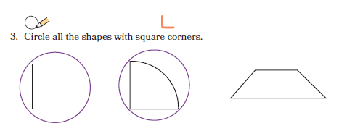
Knowledge Graph Node | Identify square corners. | Compare corners and find same-size corners.
Terminology
Mathematical Models
Strategies
Specifications | - Identify square corners in 2D shapes  - See EM2 G1 M6 L2—students use a square pattern block to verify the presence of square corners in 2D shapes  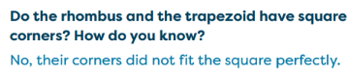    - Use square corners as a defining attribute to name, draw, describe, compare, and sort shapes | - Compare a corner to a square corner and describe it by using language such as smaller than, larger than, or the same size as  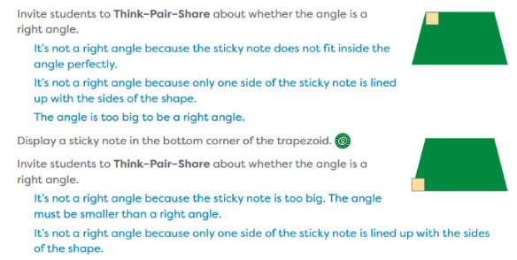  - See EM2 G2 M3 L3—students place a sticky note inside angles on classroom objects and 2D shapes.  - (Note this lesson uses “right angle” which is not defined yet.)  - Compare a non-square to a non-square corner and describe it by using language such as smaller than, larger than, or the same size as  - Lay corners on top of one another to concretely match corners of the same size  - Align vertices and one side  - Use transparencies that students can manipulate  - Analyze and compare the corners of shapes  - Learning Trajectories website has a printout of various angles for comparing/matching—could be helpful for ideas
Leaves to Include
Considerations | - Doug & Julie: children progress through using angles implicitly (often via perpendicular/parallel alignment), then matching angles, then comparing sizes while disentangling angle size from side length. they warn about misconceptions like judging angle size by ray length or by distance between endpoints.  - Baldridge ~G3: make a right angle by folding, then compare other angles by aligning vertices and sides.  - CAUTION: Don’t use the word “(right) angle” until we have a definition for it. “(square) corner” is a-ok as a squishy everyday word. No “(90) degrees” until degrees are defined (g4 ccssm).  - Students often think orientation changes angle size; rotate the template to show invariance.  - Avoid “skinny triangle has small angles because sides are short” reasoning—call it out with counterexamples.  - Could do:  - ID Perpendicular lines in the room (floor/wall edges)  - Rectangle/square attributes (has 4 square corners)  - Can define angle here (two rays, same endpoint), or in next row.  - distractors: same angle but different side lengths—force attention to the angle, not segment length
Required Skills/Cases | - Given several shapes, identify/circle the ones with square corners  - Draw a shape with square corners  - Describe a shape that has square corners  - Sort shapes based on square corners/no square corners | - Given two corners, compare the sizes of each one by using language such as smaller than, larger than, or the same size as  - Square corner and non-square corner  - Non-square corner and non-square corner  - Identify corners of the same size
Misconceptions | From Learning Trajectories website:  - Two right angles in different orientations are not equal. | From Learning Trajectories website:  - Many children correctly compare angles, if all the line segments are the same length. But when the length of the line segments are different, less than half of primary grade students can correctly match. Instead, they base their judgments on the length of the segments or the distance between their endpoints.
Existing Product Reference, if any | EM2 G1 M6 L2  EM2 G1 M6 L3 | EM2 G1 M6 L2  EM2 G1 M6 L3  EM2 G2 M3 L3
Grade (or Leaf) | G1 | G1
Notes related to Standards, Grade, or Leaf | K.G.B.4  1.G.A.1  2.G.A.1  CA.K.G.4  CA.1.G.1  CA.2.G.1  FL.2.GR.1.2  TX.2.8A  TX.2.8C  AR.3.GM.2  GA.3.GSR.6.1  VA.1.MG.2.e  IN.2.G.1  ND.1.GM.G.3  OH.2.G.1  SC.1.MGSR.2.3  SC.1.MGSR.2.5  VA.2.MG.4.b  VA.2.MG.4.d  VA.3.MG.4.e  VA.4.MG.5.d.ii  VA.4.MG.6.c | K.G.B.4  1.G.A.1  2.G.A.1  CA.K.G.4  CA.1.G.1  CA.2.G.1  SC.1.MGSR.2.5  VA.2.MG.4.b  VA.2.MG.4.d  VA.3.MG.4.e  VA.4.MG.5.d.ii  VA.4.MG.6.c
Notes for Intervention, Extension, or Optional Activities | Intervention  - From Learning Trajectories website: Mr.Mix-Up-Angles and Shapes [Angle Recognizer–More Contexts]  Intervention, Extension or Optional Activities  - Use straws, geoboards (or dot paper), or craft sticks to create shapes with 1 square corner, 2 square corners, no square corners. (EM2 G1 M6 Overview Before This Module)  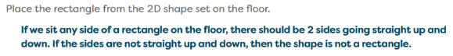  - The floor test is an informal way to get students thinking about right angles. (EM2 GK M2 TA L4 Teacher Note)  - Differentiation: Challenge margin box (G2 M3 TA L3) | Intervention  From Learning Trajectories website: Mr.Mix-Up-Angles and Shapes [Angle Recognizer–More Contexts]  Intervention, Extension or Optional Activities  - Compare corners from pattern blocks, tangrams, or cutout shapes. (EM2 G1 M6 Why)  - Create shapes and compare the corners formed using a geoboard or dot paper. (EM1 G1 M6 L3)
Additional Notes | Fluency Ideas  - Show Me Attributes (see EM2 G1 M6 L3)  - Choral Response: Shapes and Attributes (see EM2 G1 M6 L3)  Instructional Period  - 1-2  Associated Concepts from Other Stems:  - Shape classification (rectangles, squares)  - Parallel/perpendicular (informal)  - Congruence-as-superposition | Fluency Ideas  - Show Me Attributes (see EM2 G1 M6 L3)  - Choral Response: Shapes and Attributes (see EM2 G1 M6 L3)  Instructional Period  - 1  Associated Concepts from Other Stems:  - Shape classification (rectangles, squares)  - Parallel/perpendicular (informal)  - Congruence-as-superposition

Concept/Skill:

Identify, draw, and name angles, points, lines, line segments, and rays.

Goals | - draw an angle from a point by drawing two rays  - identify vertex and sides in a diagram and in shapes  - name an angle (e.g., ∠ABC) with the vertex in the middle; interpret named angles in figures
Student-Facing Example | 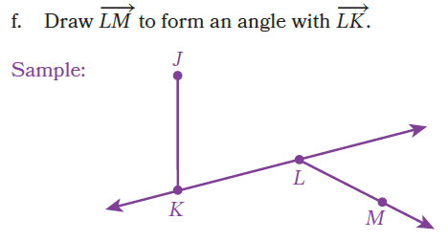
Knowledge Graph Node | Identify, draw, and name points, lines, line segments, and rays. | Identify, draw, and name angles.
Terminology | Will need definitions for point, line, line segment, and ray | Baldridge’s elementary-school definition: “an angle is two rays with the same endpoint … the endpoint is the vertex,” with an arc marking which region/angle is intended. [probs will need to revisit in MS/HS, but for elementary I think this’ll be fine. Wu includes the region but I don’t think we need it here. -ds]
Mathematical Models | Geometric notation to name points, lines, line segments, and rays | Geometric notation to name angles
Strategies
Specifications | Pointsàline segmentsàlinesàrays
Leaves to Include |  | - Relate to real-world contexts
Considerations | - CCSSM: G4 includes drawing/identifying points, lines, segments, rays, and angles. | - Define angle no later than here. Don’t use the word until it is defined.
Required Skills/Cases | - Identify each object in isolation (define)  - Name using notation  - Given a description, draw each object  - Identify each object in two-dimensional figures  - Include cases with different orientations and varying lengths (of lines, line segments, and rays) | - Define an angle  - Name using notation  - Name angle by using 1 point  - Name angle by using 3 points  - Draw an angle from a given point  - Identify vertex and rays in given angle  - Identify angles in two-dimensional figures (find and name an angle)  - Interpret angles in two-dimensional figures (given the angle, find it in the diagram)  - Include cases with different orientations and different side lengths
Misconceptions | - Using length-based reasoning to name objects (e.g., longer means line)  - Confusing line, line segment, and ray by calling all of them lines.
Existing Product Reference, if any | - EM2 G4 M6 L1 (includes angles) | - EM2 G4 M6 L1 (Draw and Label Rays and Construct an Angle; Points, Line Segments, Lines, Rays, and Angles in Familiar Figures)  - EM2 G4 M6 L2 (Use a Right-Angle Tool: angle naming conventions and definition of vertex)
Grade (or Leaf) | 4 (3 for some states) | 4
Notes related to Standards, Grade, or Leaf | CCSS.4.G.A.1  CA.4.G.A.1  FL.3.GR.1.1  TX.4.6A  IN.3.G.2 -partially tagged. Does not include rays in standard  SC.3.MGSR.3.2 | CCSS.2.G.A.1  CCSS.4.MD.C.5  CCSS.4.G.A.1  CA.2.G.1  CA.4.MD.5  CA.4.G.A.1  TX.4.6A  TX.4.7A
Notes for Intervention, Extension, or Optional Activities | - Intervention: sort activities (given images of objects, sort into categories of points, rays, line segments, and lines); Show Me Geometric Figures Fluency (see EM2 G4 M6 L2)
Additional Notes | Likely 1 instructional period | Likely 1 instructional period

Concept/Skill:

Relate an angle to a fraction of a complete turn through a circle and write an angle measure using degrees

Goals | - interpret 360° as one full turn; 180° as a straight turn; 90° as a quarter turn  - connect familiar fractions of a turn (1/4, 1/2, 3/4) to 90°, 180°, 270°  - understand degree as a unit
Student-Facing Example | 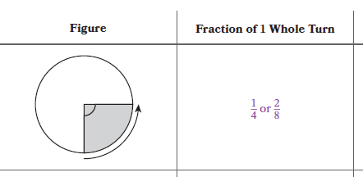
Knowledge Graph Node | Relate an angle to a fractional turn through a circle. | Write angle measures with degrees and name benchmark angles.
Terminology |  | A degree is a unit that measures an angle. An angle that turns through 1/360 of a circle is a one-degree angle, and an angle that turns through n one-degree angles measures n degrees.
Mathematical Models |  | Protractor
Strategies
Specifications | - See bullet about turning in the Big Ideas section above  - TX wants: Illustrate the measure of an angle as the part of a circle whose center is at the vertex of the angle that is “cut out” by the rays of the angle | - See bullet about measuring angles in the Big Ideas section above  - Students have not related “of” to fraction multiplication yet or found a fraction of a whole number  - Include understanding a degree as a unit of angle measure (not in the node language since “understand” is difficult to assess  - Don’t actually use a protractor to measure angles
Leaves to Include | Clocks
Considerations |  | - CCSSM G4: angle measure via a circle: one-degree angle is 1/360 of a circle; angle measure is the number of degrees.  - Iterate benchmark units: 10° hops, 30° hops, 45° via halving 90° etc.  - Can estimate first using benchmarks (near 90? near 180?)  - Can connect to number line  - Can address angle measure additivity assumption here if needed – light touch here ok, addressed more fully below
Required Skills/Cases | - Benchmarks quarter turn, half turn, three-fourths turn, full turn  - Optional: turns that are multiples of eighths | - Relate 1 degree to 1/360 of a circle  - Relate benchmark turns (90º, 180 º, 270 º, 360 º; optional 45 º, 135 º, 225 º, 315 º) to degrees (fraction of a turn, fraction of a circle, angle measure—if instructional sequence has introduced acute, right, obtuse could include those categorizations)  - Relate n degrees to n/360 of a circle
Misconceptions |  | - Segment/Ray length shown has something to do with angle size  - Orientation matters to angle size
Existing Product Reference, if any | EM2 G4 M6 L7 (consider technology instead of concrete tool | EM2 G4 M6 L8 (less about the protractor itself, more about the fraction/degree relationships)
Grade (or Leaf) | 4 | 4
Notes related to Standards, Grade, or Leaf | CCSS.4.MD.C.5.a  TX.4.7A  NE.4.G.2.b  Clocks: MD.1.GR.C.5, TX.2.9G | CCSS.4.MD.C.5.a  TX.4.7B  NE.4.G.2.b
Notes for Intervention, Extension, or Optional Activities | - Clockwise and counterclockwise terminology  - Using fractions of a turn and degrees to describe turns in space (EM2 G4 M6 L9 Learn 2 and 3)  - Relate turns to acute, right, obtuse, straight, and reflex angles | - Using fractions of a turn and degrees to describe turns in space (EM2 G4 M6 L9 Learn 2 and 3)
Additional Notes | Likely 1 instructional period | Likely 1 instructional period, will also be reinforced in instruction for measuring turns by iterating degrees Concept/Skill lessons

Concept/Skill: Measure and draw angles by using a protractor

Goals | - measure an angle accurately with a protractor (including choosing the correct scale)  - draw an angle of a given measure from a ray  - explain why the protractor works (at least informally: it’s a pre-marked degree-iteration tool)
Student-Facing Example | 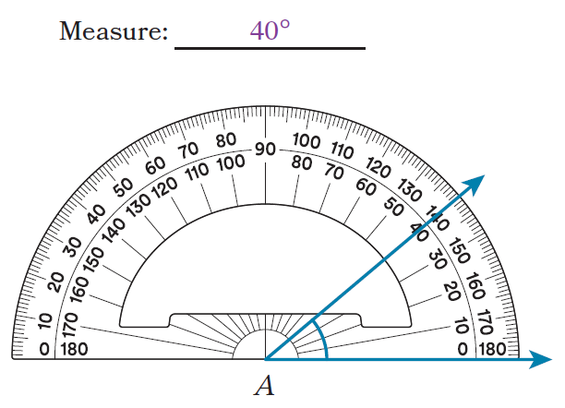
Knowledge Graph Node | Measure angles. | Draw angles with given measurements.
Terminology
Mathematical Models | Protractor | Protractor
Strategies
Specifications | - 180 degree protractor  - Relate protractor to ruler (i.e., measuring tool; a protractor iterates degrees, a ruler iterates inches/centimeters)  - Estimate before measuring (benchmarks 45, 90, 135, 180, and acute, right, obtuse)  - Extend the length of the rays to measure  - Variety of orientations | - 180 degree protractor  - Estimate/visualize/sketch before drawing  - Variety of orientations
Leaves to Include | - Full-circle protractors / reflex angles (enrichment)  - Transparent protractors over shapes/maps (D&J activities)
Considerations | - Doug & Julie: may mix up the “outside” (e.g., 270° turn) and the “inside” (90°) angle in turtle/turning contexts—great for surfacing interior/exterior ideas.  - Debug: wrong scale, misaligned vertex, measuring the exterior angle, measures rays or distance instead of degrees
Required Skills/Cases | - <90 degrees  - Between 90 and 180 degrees  - Between 180 and 360 degrees  - Measure is a labeled tick mark on protractor (multiple of 10)  - Measure is not a labeled tick mark on protractor (multiple of 5)  - Measure is not a labeled tick mark on protractor (not multiple of 5)  - One ray horizontal, angle opens to the right  - One ray horizontal, angle opens to the left  - Neither ray horizontal (including one ray vertical)  - Rays need to be extended to measure | - <90 degrees  - Between 90 and 180 degrees  - Between 90 and 360 degrees  - Measure is a labeled tick mark on protractor (multiple of 10)  - Measure is not a labeled tick mark on protractor (multiple of 5)  - Measure is not a labeled tick mark on protractor (not multiple of 5)  - 1 ray given (horizontal, vertical, neither)  - No rays given
Misconceptions | - Debug: wrong scale, misaligned vertex, measuring the exterior angle, measures rays or distance instead of degrees | - Debug: wrong scale, misaligned vertex, measuring the exterior angle, measures rays or distance instead of degrees
Existing Product Reference, if any | - EM2 G4 M6 L8 Launch (but 180 degree protractor)  - EM2 G4 M6 L10 Learn 2 and 3  - EM2 G4 M6 L11 | EM2 G4 M6 L12
Grade (or Leaf) | 4, 5 for some states | 4, 5 for some states
Notes related to Standards, Grade, or Leaf | CCSS.4.MD.C.6  FL.4.GR.1.2  TX.4.7C  OK.5.GM.3.1  VA.5.MG.3.e | CCSS.4.MD.C.6  FL.4.GR.1.2  TX.4.7D  OK.5.GM.3.1  VA.5.MG.3.e
Notes for Intervention, Extension, or Optional Activities | - Full-circle protractors / reflex angles (enrichment)  - Transparent protractors over shapes/maps (D&J activities)  - Digital protractors (if needed for assessment should be core instead of optional/extension) | - Full-circle protractors / reflex angles (enrichment)  - Digital protractors (if needed for assessment should be core instead of optional/extension)
Additional Notes | Likely 2 instructional periods | Likely 1 instructional period

Concept/Skill:

Classify angles, and draw angles made of perpendicular lines
Goals | - classify angles from measures and/or benchmarks  - find and label these angles in polygons and in the real world  - connect right angles to perpendicular lines (and rectangles/squares)
Student-Facing Example | 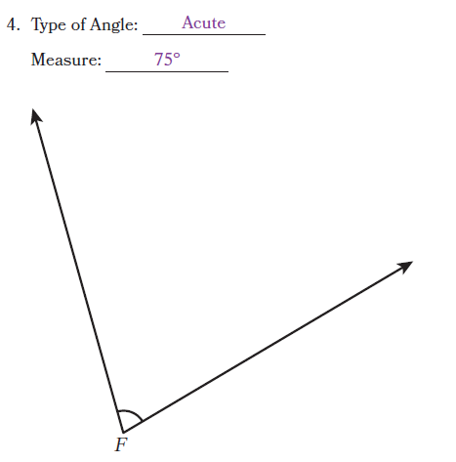
Knowledge Graph Node | Classify angles by their degree measures. | Use right angles to identify and draw perpendicular lines.
Terminology | An acute angle is an angle that measures less than 90 degrees. (similarly obtuse, right, straight) | Need definition for perpendicular lines
Mathematical Models | Protractors | Protractors  Grid paper
Strategies
Specifications |  | - Perpendicular line notation  - Drawing perpendicular lines on grid paper and on blank paper
Leaves to Include | - Triangle classification by angle measures (acute/right/obtuse triangles)  - Quadrilateral classification (rectangles have 4 right angles) | - Parallel/perpendicular reasoning in grids
Considerations | - Define: acute, obtuse, right, straight angles. (using degree measure)  - CCSSM G4: includes identifying points/lines/rays/angles and classifying figures based on angle measures, including right, acute, obtuse.  - Doug & Julie: “straight” can be hard - students may treat “straight” as “upright” rather than 180°.  - CAUTION: do not conflate angle (geometric object) vs angle measure (number)
Required Skills/Cases | - Identify a given angle as acute, right, obtuse, or straight (by measuring or using a right-angle tool)  - Draw acute, right, obtuse, and straight angles  - Identify acute, right, obtuse, and straight angles in two-dimensional figures and the real world  - Include cases with different orientations and different side lengths | - Identify perpendicular line segments, lines, and rays  - Draw perpendicular line segments, lines, and rays  - Identify perpendicular lines in two-dimensional figures and the real world  - Include cases with different orientations
Misconceptions |  | - Perpendicular means any two lines that intersect  - Perpendicular only applies to vertical and horizontal lines
Existing Product Reference, if any | EM2 G4 M6 L2 and L3 (relies on right-angle tool, not protractor) | EM2 G4 M6 L4 (does not include angle measurement)
Grade (or Leaf) | 4 (3 for some states) | 4 (3 for some states)
Notes related to Standards, Grade, or Leaf | CCSS.4.G.A.1  CA.4.G.1  FL.4.GR.1.1 (includes reflex)  TX.4.6C  GA.3.GSR.6.1  ND.3.GM.G.1  OK.3.GM.1.3  SC.3.MGSR.3.1 | CCSS.4.G.A.1  CA.4.G.1  FL3.GR.1.1  TX.4.6A  AR.3.GM.2  GA.3.GSR.6.1  ND.3.GM.G.1  OK.3.GM.1.3  SC.3.MGSR.3.1  VA.4.MG.4.d
Notes for Intervention, Extension, or Optional Activities | - Intervention: Classify angles by comparing them to a right-angle tool (square corner) as a benchmark (smaller than, equal to, or larger than).  - Optional: include reflex angles (Florida requires this) | - Intervention: use right-angle tools to test for right angles
Additional Notes | Likely 1 instructional period  OR  Embedded in other instructional periods  The permissions for the art in G4 M6 L2 Problem Set/Land had some restrictions that made it less than ideal to use; if a similar activity is desired, find different art | - Likely 1 instructional period  - Needs to connect to classifying shapes

Concept/Skill:

Compose and decompose angles to find unknown angle measures.

Goals | - decompose and compose angles and add/subtract measures correctly  - solve unknown angle problems (including multi-step), with justification  - represent reasoning with equations when appropriate (bridge to algebraic thinking)
Student-Facing Example | 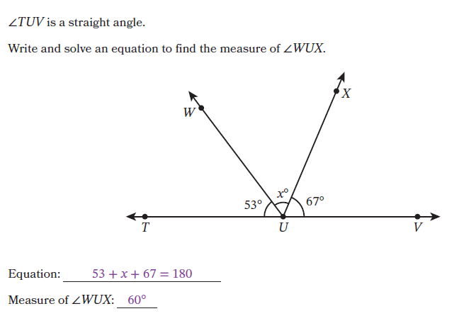
Knowledge Graph Node | Compose and decompose angles to find unknown angle measures.
Terminology | Adjacent angles share a vertex and a side. [could use “concatenation” language here if you want to be spicy -ds]  Need definitions for complementary and supplementary angles
Mathematical Models | - Equations!  - Protractors  Additivity of angles is a mathematical assumption we make. It’s not something we prove, or reason our way to. We can use protractors and pictures to suggest why it might be a good assumption to make, but angle additivity is a stipulation (there are mathematical universes in which angle additivity does not hold!)
Strategies | Steps:  - label known parts  - write an equation m∠ABD = m∠ABC + m∠CBD  - solve by subtraction  - check with diagram
Specifications | Understand that angle measure is additive (not part of node language since understand is not assessable)  Problem types:  - Unknown part (or parts)  - Unknown total
Leaves to Include
Considerations | - CCSSM G4: explicitly expects recognizing angle measure as additive and solving for unknown angles in decomposed diagrams.  - Wu: if a point C is inside ∠AOB, then |∠AOC| + |∠COB| = |∠AOB|. (but note: Wu’s angle is the region so we won’t use this formulation until MS/HS)  - So go with Baldridge: adjacent angles add; if ∠ABC and ∠CBD are adjacent then m∠ABD = m∠ABC + m∠CBD.  - “non-overlapping parts” matters—without it, additivity fails.  - D&J: students may add based on side lengths or misread the angle that’s actually intended. could mark the angle with an arc as a norm.  - Unknown angle puzzles in polygons / around a point  - Complementary and supplementary as special cases
Required Skills/Cases | - Decompose acute, right, obtuse, straight, and reflex angles into 2 or more non-overlapping angles  - Add the smaller known angle measures to find the larger unknown angle measure  - Find unknown angle measures within right and straight angles  - Find unknown angle measures within acute, obtuse, and reflex angles  - Find unknown angle measures around a point  - Complementary and supplementary as special cases
Misconceptions | - Students believe proximity implies additivity, ignoring structure (adding angles that are near each other, but not adjacent)
Existing Product Reference, if any | - EM2 G4 M6 L14  - EM2 G4 M6 L15  - EM2 G4 M6 L16
Grade (or Leaf) | 4
Notes related to Standards, Grade, or Leaf | CCSS.4.MD.C.7  CA.4.MD.7  FL.4.GR.1.3  TX.4.7E
Notes for Intervention, Extension, or Optional Activities | - Intervention: physically decompose angles (could use pattern blocks like in EM2 G4 M6 L13); focus first on identifying structure before solving  - Optional/Extension: real-world contexts
Additional Notes | Likely 2 instructional periods

